|  |  |  |  |
| --- | --- | --- | --- |
| 1 | | 19,032 | |
| **NUMERO DE FRONTERAS** | | **ENERGIA AGREGADA** | |
|  | | | |
| 62,842,941 | 150 | | 2,580,855 |
| INGRESO 2020 | DÍAS CERTIFICADOS 2020 | | ENERGIA RESPALDADA 2020 |
|  | | | |
| 69,660,663 | 160 | | 3,044,817 |
| INGRESO 2021 | DÍAS CERTIFICADOS 2021 | | ENERGIA RESPALDADA 2021 |

**HISTORICO REINTEGRO DDV**

|  |  |  |
| --- | --- | --- |
|  | **2020** | **2021** |
| **ENE** | - | 6.8 |
| **FEB** | - | 9.83 |
| **MAR** | - | 4.85 |
| **ABR** | - | 0.47 |
| **MAY** | 3.88 | 8.71 |
| **JUN** | 10.07 | 10.28 |
| **JUL** | 10.83 | 5.04 |
| **AGO** | 8.98 | 5.08 |
| **SEP** | - | 11.58 |
| **OCT** | 10.58 | 7.02 |
| **NOV** | 9.36 | - |
| **DIC** | 9.14 | - |

**Los valores de la tabla están en millones de COP**

**REINTEGRO MECANISMO DDV OCTUBRE 2021**

|  |  |  |  |  |  |
| --- | --- | --- | --- | --- | --- |
| FECHA | TIPO DIA | CANTIDADES RESPALDO | PRECIO PONDERADO USD | TRM | PNETO |
| 2021-10-06 | Miércoles | 19,030 | 5.98 | 3,784.44 | 390,184 |
| 2021-10-07 | Jueves | 19,030 | 5.98 | 3,784.44 | 390,184 |
| 2021-10-08 | Viernes | 19,027 | 5.98 | 3,784.44 | 390,123 |
| 2021-10-09 | Sábado | 19,030 | 5.98 | 3,784.44 | 390,184 |
| 2021-10-10 | Domingo - Festivo | 19,031 | 5.98 | 3,784.44 | 390,205 |
| 2021-10-11 | Lunes | 19,031 | 5.98 | 3,784.44 | 390,205 |
| 2021-10-18 | Domingo - Festivo | 19,030 | 5.98 | 3,784.44 | 390,184 |
| 2021-10-19 | Martes | 19,031 | 5.98 | 3,784.44 | 390,205 |
| 2021-10-20 | Miércoles | 19,031 | 5.98 | 3,784.44 | 390,205 |
| 2021-10-21 | Jueves | 19,030 | 5.98 | 3,784.44 | 390,184 |
| 2021-10-22 | Viernes | 19,030 | 5.98 | 3,784.44 | 390,184 |
| 2021-10-23 | Sábado | 19,030 | 5.98 | 3,784.44 | 390,184 |
| 2021-10-24 | Domingo - Festivo | 19,030 | 5.98 | 3,784.44 | 390,184 |
| 2021-10-25 | Lunes | 19,030 | 5.98 | 3,784.44 | 390,184 |
| 2021-10-26 | Martes | 19,030 | 5.98 | 3,784.44 | 390,184 |
| 2021-10-27 | Miércoles | 19,031 | 5.98 | 3,784.44 | 390,205 |
| 2021-10-28 | Jueves | 19,031 | 5.98 | 3,784.44 | 390,205 |
| 2021-10-29 | Viernes | 19,031 | 5.98 | 3,784.44 | 390,205 |

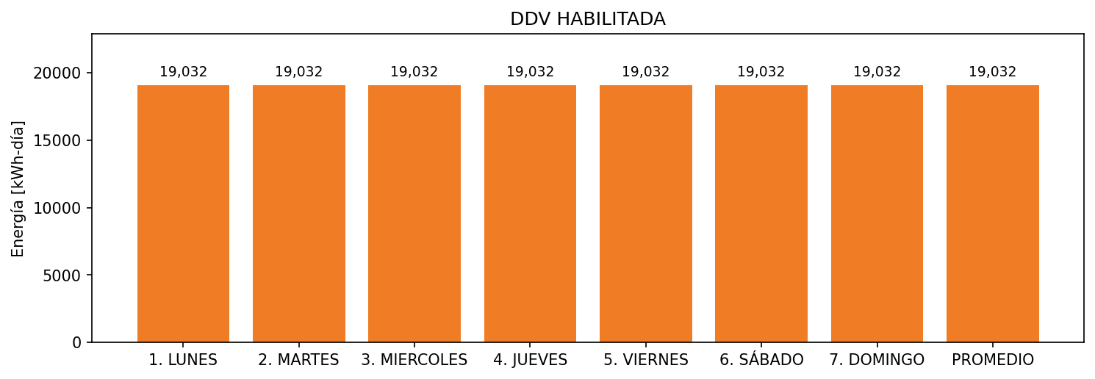

|  |  |  |  |  |  |  |  |  |  |
| --- | --- | --- | --- | --- | --- | --- | --- | --- | --- |
| **FRONTERA** | **COD SIC** | **FRT DDV** | **TIPO DDV** | **PROMEDIO** | **PRÓXIMA ACTUALIZACIÓN** | **MARGEN DE ERROR** | **ÚLTIMA PRUEBA DDV** | **DÍAS PARTICIPACIÓN** | **FECHA REFERENCIA PRÓXIMA PRUEBA DDV** |
| ALIMENTOS BALANCEADOS TEQUENDAMA S.A. - BALSILLAS | Frt07836 | Frt39047 | GPE | 19,032 | 2026-04-15 | NO APLICA | 2021-07-23 | 55.0 | 2022-01-10 |